**Types of Entrepreneurs**

Starting a business all on your own is a very difficult task. An entrepreneur needs to have a lot of skills and knowledge to get the business off the ground. But if the kind of business the entrepreneur is setting up matches with his personality, his nature, then the job becomes somewhat easier.

So identifying your skills, characteristics and personality traits can help an entrepreneur also identify the type of business he should start. Each of these types of entrepreneurs will enjoy success if they remain true to their characters. Let us see some of the most common types of entrepreneurs.



*(Source: BPplans)*

**1. Idealist**

An idealist is one of the most common types of entrepreneurs. He is generally innovative and creative by nature. His idealistic nature usually guides his innovative spirit to pursue his entrepreneurship dreams. And such idealist entrepreneurs are also optimistic by nature.

**2. Optimizer**

These are the entrepreneurs that see the glass as half full. They have a very positive outlook on life and this optimistic nature of their reflects in their business as well. They are also usually content with owning a business; they derive personal satisfaction from it.

**3. Hard Workers**

While all types of entrepreneurs work hard for their respective business, this is a special kind of hard worker. As the name suggests, these are the entrepreneurs that put maximum effort to ensure their business succeeds.

They do not mind the long hours and the toil involved with building a business. They constantly challenge themselves and work endlessly to ensure the growth of their business.

**4. Improver**

These types of entrepreneurs have a noble cause to start their business – to improve or better the world in some way. They wish to run a moral and ethical business. Such entrepreneurs are very ethical. They will not adopt means that harm the cause in the search for higher profits.

**5. Visionary**

These are the entrepreneurs that are the founding members of the business. It was their vision and objectives that were followed to build the business. These people have the ability to accurately gauge the future and are also generally curious by nature. They are the original thinkers of the business.

**6. Analyst**

And finally the analysts. These are the problem solvers. They analyze the problems and complications and find the most suitable and cheap solutions. They are critical thinkers and logical people by nature. Also, complicated businesses suit them since they are not bothered by too many complications.

**7. Jugglers**

A juggler is an entrepreneur that likes to handle everything by himself. They are energetic and enthusiastic entrepreneurs who do not believe in having too many employees or help. So they handle everything from ensuring project finance to paying the daily bills.

**Types of Entrepreneurs**

**Definition:**An Entrepreneur is a person who has a role of an industrialist and forms an organization for the commercial use.

He is a change agent who transforms the demand into supply by forecasting the needs of the society.

**Types of Entrepreneurs**

[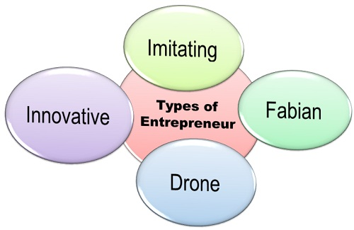](https://businessjargons.com/wp-content/uploads/2015/12/Types-of-Entrepreneur.jpg)

1. **Innovative Entrepreneur:**These are the ones who invent the new ideas, new products, new production methods or processes, discover potential markets and reorganize the company’s structure. These are the industry leaders and contributes significantly towards the economic development of the country.The innovative entrepreneurs have an unusual foresight to recognize the demand for goods and services. They are always ready to take a risk because they enjoy the excitement of a challenge, and every challenge has some risk associated with it. Ratan Tata is said to be an innovative entrepreneur, who launched the Tata Nano car at a considerably low cost.
2. **Imitating Entrepreneurs:** The imitating entrepreneurs are those who immediately copy the new inventions made by the innovative entrepreneurs. These do not make any innovations by themselves; they just imitate the technology, processes, methods pioneered by others. These entrepreneurs are found in the places where there is a lack of resources or industrial base due to which no new innovations could be made. Thus, they are suitable for the underdeveloped regions where they can imitate the combinations of inventions already well-established in the developed regions, in order to bring a boom in their industry.
3. **Fabian Entrepreneurs:** These types of entrepreneurs are sceptical about the changes to be made in the organization. They do not initiate any inventions but follow only after they are satisfied with its success rate.They wait for some time before the innovation becomes well tested by others and do not result in a huge loss due to its failure.
4. **Drone Entrepreneurs:** These entrepreneurs are reluctant to change since they are very conservative and do not want to make any changes in the organization. They are happy with their present mode of business and do not want to change even if they are suffering the losses.

**This classification is done on the basis of the willingness of an entrepreneur to create and accept the innovative ideas.**